**EX:No.1 221501047**

**25/01/25**

**PROGRAM TO IMPLEMENT TIME SERIES DATA FOR IMPORT LIBRARY, LOAD DATA, PREPROCESSING AND VISUALISING**

**PROGRAM AND OUTPUT:**

import pandas as pd

import matplotlib.pyplot as plt

file_path = 'Super_Store_data.csv'

data = pd.read_csv(file_path, encoding='latin1')

print("Initial Data:")

print(data.head())

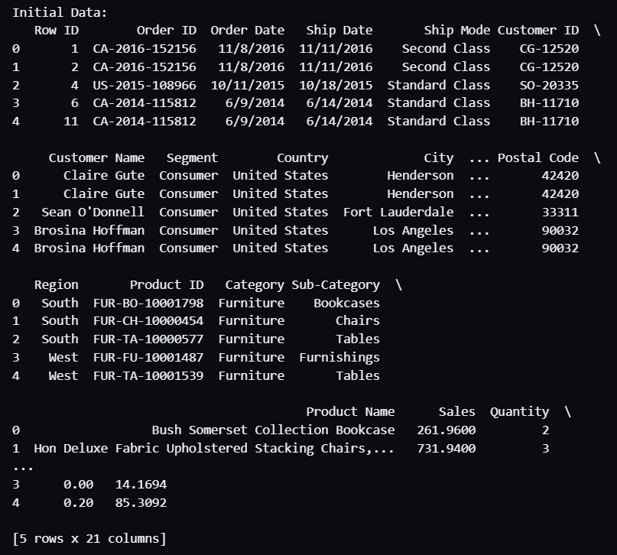

print(data.isnull().sum())

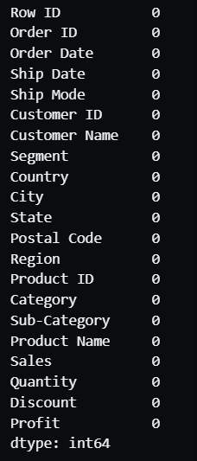

data.fillna(method='ffill', inplace=True)

data.fillna(method='bfill', inplace=True)

date_column = 'Order Date'

data[date_column] = pd.to_datetime(data[date_column], errors='coerce')

data = data.dropna(subset=[date_column])

data.set_index(date_column, inplace=True)

data.sort_index(inplace=True)

print("\nCleaned Data:")

print(data.head())

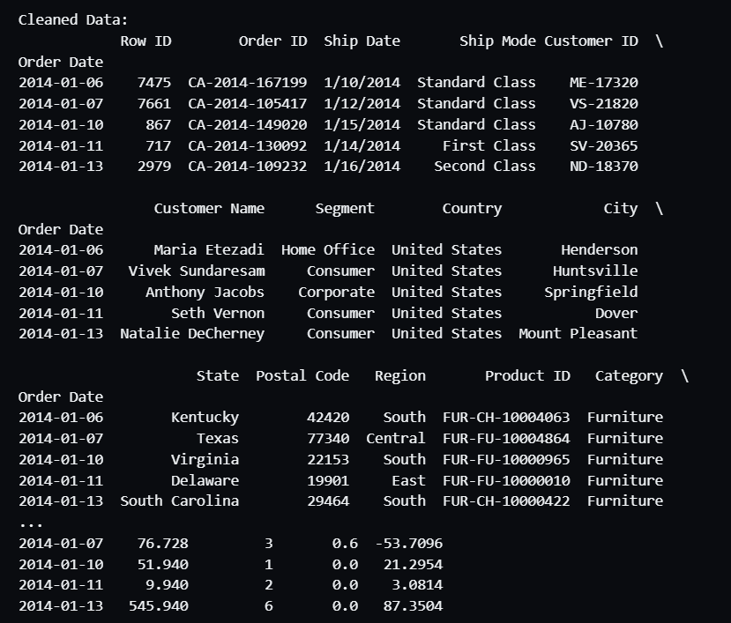

numerical_column = 'Sales'

if numerical_column in data.columns:

    plt.figure(figsize=(10, 6))

    data[numerical_column].plot()

    plt.title(f'Time Series of {numerical_column}')

    plt.xlabel('Date')

    plt.ylabel(numerical_column)

    plt.grid()

    plt.show()

